COLONIAL SOIL AND WATER CONSERVATION DISTRIC
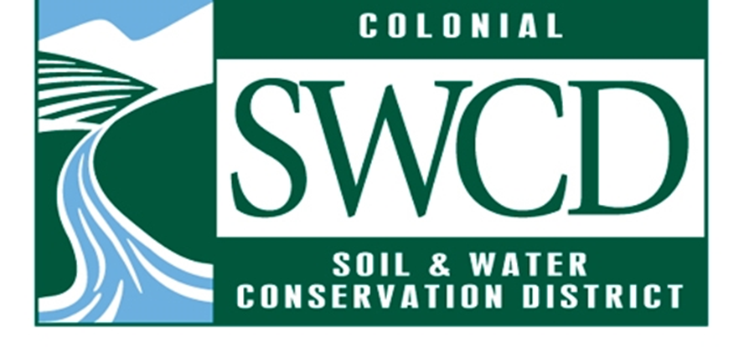
ANNUAL PLAN OF WORK FY 2022
The Colonial Soil & Water Conservation District Annual Plan of Work for fiscal year 2022 provides the structure for the pursuit and implementation of goals and objectives. The goals, objectives, and strategies were determined by standing committees, reviewed and revised by the Planning Committee, and approved by the District board.
The successful achievement of the goals will depend on the participation and cooperation of District staff and board working together with District landowners and partners. CSWCD Standing Committee members will play a key role in establishing priorities and timelines for projects and activities that can efficiently and effectively accomplish the various goals and objectives outlined in this plan.
Committees will provide regular and timely updates to the Board on sources of additional funding, potential community partners, as well as barriers and impediments that influence project success.

Executive Committee
Time Frame | Actions – Text in Bold represents Strategic Plan Metric
July 1, 2021 to June 30 2022 | Review committee charge/charter and provide updates to District Manager, as necessary. Board will take action to approve committee charges/charters

Ag Program Committee
Time Frame | Actions – Text in Bold represents Strategic Plan Metric
July 1, 2021 to June 30 2022 | - Discussion and decision regarding how much of the FY 2022 VACS allocation we want to keep/send back/redistribute  - Seek to allocate at least 90% of FY 2022 allocation  - Seek to complete VACS carry-over practices approved in FY 2021 (SE-2, SL-8A)  - Staff will seek consensus to reduce the number of assessments conducted from 20 to 5 for each locality. Staff time constraints, given the large VACS allocation, will not allow the District to continue CBPA assessments at the present level. · The District receives $440 for each assessment, so a reduction of $19,800 in income should be expected.  - Provide technical assistance to localities by engaging with landowners to address conservation concerns and developing Conservation Plans  - Meet VEE DAPA grant deliverables  - Finish Summer 2021 Program Offering  - Complete Grand project final report  - District staff will organize education opportunity for District Board and perhaps others (i.e. Master Gardeners)  - Stay abreast of grant opportunities in Ag Industry (ex. Precision Ag, Carbon markets, Small Farm Operations, etc.)  - Collaborate with new VCE ANR Agent, VSU SFOP Agriculture Management Agent, and relevant partners to provide technical assistance to small farming operations  - Seek to attain/maintain technical certifications  - Stay abreast of grant opportunities in Ag Industry (ex. Precision Ag, Carbon markets, etc.)  - Identify parcels and execute CBPA Ag Land Assessments

Education & Outreach Programs Committee
Time Frame | Actions – Text in Bold represents Strategic Plan Metric
July 1 – September 30, 2021 | - Seek initiative or program to focus direction of Education Program Committee  - Complete a minimum of 3 educational events with WCG  - Begin evaluation of District website and develop/execute plan for its improvement  - Develop strategy to promote other conservation education programs including poster contest, YCC, scout merit badges, W&M Earth Day  - Engage with community leaders and representatives to form a Community Focus Group or Advisory Board to seek expertise and gather feedback during implementation of Chesapeake Bay License Plate grant (target at least 5 community groups, organizations, or businesses with whom CSWCD has not previously collaborated)  - Collaborate to identify target audiences, priority messages, and appropriate engagement strategies  - Develop and conduct baseline survey about knowledge of CSWCD programming, soil & water conservation issues  - Begin orienting and onboarding William & Mary student volunteer
October 1– December 31, 2022 | - Develop outreach and educational materials for printing and online platforms  - Develop strategy to promote Envirothon program to area schools and continue to support current team(s)  - Hire translators to interpret and make materials culturally accessible to community members for whom English is not the primary language  - Provide feedback and guidance to William & Mary student volunteer on activities and other SWCD contributions  - Consult with Community Focus Group for feedback and guidance (1 public meeting)  - Review PY2022 APOW
January 1 – March 31, 2022 | - Finalize printing outreach materials  - Distribute printed materials via mailers and placing in at least 10 community spaces where none currently exist (at least 300 flyers, brochures, etc. total)  - Advertise and share educational content on virtual platforms (at least 20 new audience-appropriate pieces by end of project)  - Consult with Community Focus Group for feedback and guidance (1 public meeting) · Advise and oversee Volunteers
April 1 – June 30, 2022 | - Monitor access to and use of materials placed in public spaces  - Develop and conduct post-project survey to assess change in target audience knowledge of CSWCD programming and general soil & water conservation  - Consult with Community Focus Group for feedback of project and guidance in determining next steps  - Incorporate successes and lessons learned into ongoing and new education and outreach initiatives  - Advise and oversee Volunteers  - Complete assessment of District education program and make recommendations to BoD  - Review committee charge/charter and provide updates to District Manager, as necessary. Board will take action to approve committee charges/charters  - Review PY2022 APOW and develop PY2023 APOW

Urban Programs Committee
Time Frame | Actions – Text in Bold represents Strategic Plan Metric
July 1, 2021 to June 30 2022 | - Continue to implement Turf Love in JCC  - Continue to implement VCAP  - Continue board member interactions with local decision makers and staff  - Implement SEP  - Execute SEP focused Ches. Bay License Plate grant  - Implement USDA Urban Ag grant if funded  - Consider collaborating with WCG in seeking funding to continue Urban Agriculture Technician.  - Execute SEP focused NFWF Small Watershed Grant if funded  - Seek additional grants & local support to continue & improve funding for SEP, Turf Love, and VCAP  - Seek novel ways to engage local government officials  - Review committee charge/charter and provide updates to District Manager, as necessary. Board will take action to approve committee charges/charters  - Seek opportunities for reaching more diverse pool of potential applicants with offered programs.  - Collaborate with MG chapters and Peninsula Master Naturalist about attracting more diverse pool of volunteers  - Assess effectiveness of pre site visit questionnaire and resume effort to develop and implement strategies to create additional efficiencies in the VCAP application process  - Evaluate the need for committing additional staff resources or volunteers to Urban Programs  - Continue to consult other Districts to acquire program information and resources about Turf Love, SEP, & other programs

Finance Committee
Time Frame | Actions – Text in Bold represents Strategic Plan Metric
July 1, 2021 to June 30 2022 | - Develop a 5-year financial needs assessment to sustain District operations  - Complete deliverables of FY 2022 DCR Operations Grant  - Evaluate current office space and alternative options  - Review committee charge/charter and provide updates to District Manager, as necessary. Board will take action to approve committee charges/charters
Note: The Finance Committee will review and recommend action to the BoD before the end of the FY regarding the Vehicle Use Policy, but there are deeper issues tied to the Vehicle Use Policy that are of a personnel nature that will need to be addressed in FY 2022 as the VEE DAPA grant ends, the currently leased truck is purchased by the District, where the truck is garaged, and if personal use of the truck will be allowed as a compensable benefit.
Nominating Committee
Time Frame | Actions – Text in Bold represents Strategic Plan Metric
July 1, 2021 to June 30 2022 | - Provide slate of officers for upcoming year before last BoD meeting of 2021  - Review committee charge/charter and provide updates to District Manager, as necessary. Board will take action to approve committee charges/charters

Personnel Committee
Time Frame | Actions – Text in Bold represents Strategic Plan Metric
July 1, 2021 to June 30 2022 | - Meet deliverables of FY 2022 DCR Operations grant  - Review committee charge/charter and provide updates to District Manager, as necessary. Board will take action to approve committee charges/charters  - Review and recommend appropriate changes to the District’s Vehicle Use Policy.  - Review compensation equity among CSWCD staff

Planning Committee
Time Frame | Actions – Text in Bold represents Strategic Plan Metric
July 1, 2021 to June 30 2022 | - Review FY 2022 APOW-to be done quarterly in APOW 2022  - Review Strategic Plan-to be done quarterly in APOW 2022  - Develop FY 2023 APOW with input from committees & staff  - Review committee charge/charter and provide updates to District Manager, as necessary. Board will take action to approve committee charges/charters  - Start the process of Succession Planning for Directors and Staff in the first quarter of FY 2022.

Operations/Staff
Time Frame | Actions – Text in Bold represents Strategic Plan Metric
July 1, 2021 to June 30 2022 | - Keep BoD members abreast of progress toward meeting grant deliverables and obligations  - Create and distribute FY 2021 Annual Report  - Purchase the Toyota Tacoma truck currently leased through the VEE DAPA grant
The Commonwealth of Virginia supports the Colonial Soil & Water Conservation District though financial and administrative assistance provided by the Department of Conservation & Recreation. The Virginia Soil and Water Conservation Board supports the Colonial Soil and Water Conservation District through their oversight and support, including financial support, coordination and information exchange.

All programs and services of the Colonial Soil & Water Conservation District are offered on a nondiscriminatory basis without regard to race, color, national origin, religion, sex, age, marital status or handicap.

Approved by the Colonial Soil & Water Conservation District Board of Directors on June 22, 2021

Colonial Soil & Water Conservation District
Chairman of the Board, Charles Carter

Signed______________________________________Date___________________

