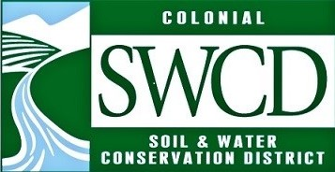
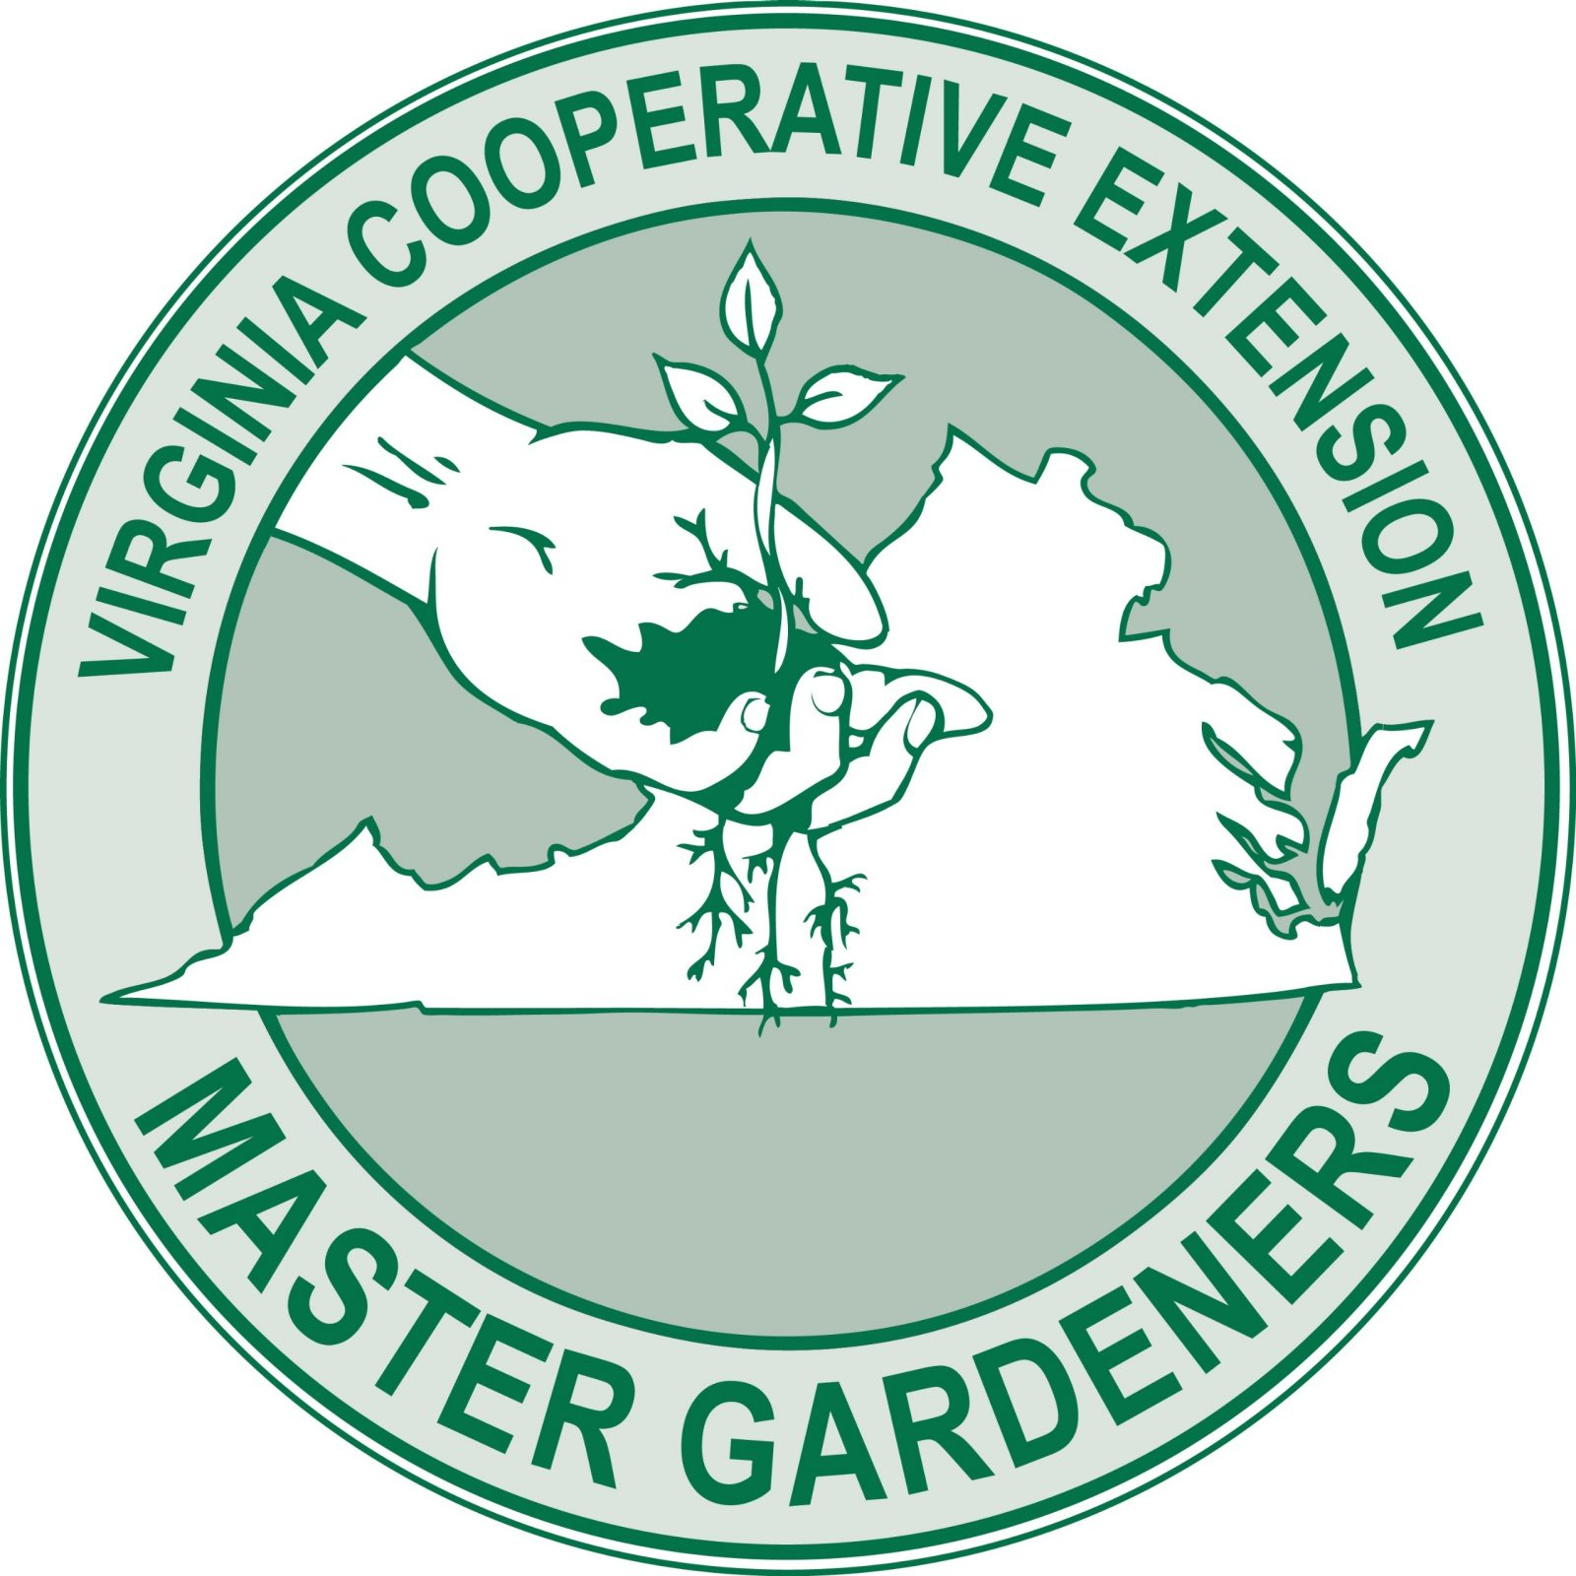
Shoreline Evaluation Program Registration
Colonial Soil and Water Conservation District
205 Bulifants Blvd, Suite C, Williamsburg VA 23188
(757) 645-4895
Robyn.Woolsey@colonialswcd.org

The Shoreline Evaluation Program (SEP) provides technical and educational assistance to shorefront property owners by assessing current or potential threats to the property and identifying opportunities onsite to help improve water quality locally and in the greater Chesapeake Bay. With training from the Virginia Institute for Marine Science and the Virginia Cooperative Extension, SEP volunteers provide an on-site evaluation of property protection from both seawater and stormwater. Following the site visit, a written report is prepared with specific shorefront protection recommendations. Included with the report is a copy of the SEP Homeowner’s Shorefront Management Guide which contains extensive shorefront protection and landscape information.

To register, please complete this form and the attached questionnaire and mail them to the address below together with a check for $75 made payable to Colonial SWCD. This fee covers the costs of the evaluation materials, soil sample analysis, printing, and postage.
Colonial Soil and Water Conservation District
Shoreline Evaluation Program
205 Bulifants Blvd, Suite C
Williamsburg, VA 23188

Name:_______________________________________________________________________________
Address_______________________________________________City:________________Zip________
Phone: (______)_________________ E-mail:__________________________________________________
Best time to call to schedule an evaluation: ________________________________
- Please check if you agree to a follow-up visit during the 12 months after the evaluation so that we may obtain your feedback and determine whether the report and the recommendations were of value to you.
- Please check if you want to received emails about other Colonial SWCD programs and activities.
__________________________________________________________________________________________________________________________
Office Use Only:
Received: __________________ Date of Visit: ___________ Check #: _______ Amount: $_______
SEP Team: ____________________________ and __________________________
Recommendations provided:
(date)

Shoreline Evaluation Program
Questionnaire

Please complete this questionnaire as best as you can and return it to the Colonial Soil and Water Conservation District with the registration form and your payment. Do not worry if you do not have all the information, just try and give us as complete a picture of your property as possible.

If possible, please attach photographs that illustrate your concerns.

Name: _________________________________________________________________________________
Address of Property: _____________________________________________________________________
County: ______________________ Body of water: ____________________________
Is this a part time home? No___ Yes ___
If yes, what is your preferred mailing address?
________________________________________ City: _____________________ Zip: ___________
How long have you owned the property? ____________ What is the size of the property? ________________
How far is your house from the mean high tide line? _______ feet
Briefly describe your shoreline concerns: __________________________________________________________________________________________________________________________________________________________________________________________________________________________________________________________________________________________________________________________________________________________________________________________________________________________________________________________________________________________________________________________________________________________________

Shoreline Questions:
Has your shoreline noticeably receded during the past two years? No____ Yes ____
Is your shoreline vulnerable to storms? No____ Yes ____
Do you have frequent boat traffic? No____ Yes ____
What is the length of your shoreline? _______ feet
Which direction does your shoreline face (circle all that apply): N S E W
Please list the type of vegetation present on your shoreline.
_____ mature canopy trees _____ mid-story trees _____ shrubs
_____ ground covers _____ marsh grass _____ turf
_____ other (please describe)

Have you or previous owners implemented remedies for problems on your shoreline? (Check all that apply and indicate whether or not they are still serviceable.)

A. ____ Bulkhead
B. ____ Riprap
C. ____ Groins/jetties
D. ____ Marsh toe sill/stabilization

Do your neighbors have any of the above? (please circle all that apply)
Neighbor to the right when facing the water. A B C D
Neighbor to the left when facing the water. A B C D
Bank Conditions:
Is the height of your bank uniform? No _____ Yes ______ If yes: Height ______ feet

If the bank height is not uniform, what is the highest measurement: _______ feet, and the lowest ________ feet.

Upland Conditions:
Does your land slope down to the bank/shoreline? No____ Yes ____

Do you have gullies or channels that run down to the shoreline? No____ Yes ____

Are there gutters on your house or on other structures? No____ Yes ____

If yes, do they empty into or onto:
_____ splash blocks _____ rain barrels
_____ dry well/s _____ none of the above

What percentage of your property is lawn? __________

What is the ultimate goal for your shoreline? (circle all that apply)
A. Shoreline protection B. Shoreline restoration
C. Storm water management D. Habitat development or enhancement
E. Improved water quality F. Other

How did you hear about this program? __________________________________________________________

What outcomes are you expecting from a visit from the SEP Team?

All programs and services of the Colonial Soil and Water Conservation District are offered on a nondiscriminatory basis
without regard to race, color, national origin, religion, sex, age, marital status, or handicap

